11.3.2. Excision of a Portion of Reserve 37811 to Amalgamate with Reserve 27643

Location/Address | Shire of Augusta Margaret River
Applicant/Landowner | Blackwood River Houseboats
File Reference | RES/37811, RES/27643
Report Author | Emma Rogers, Governance (Legal, Risk and Permit) Officer
Authorising Officer | Ian McLeod, Manager Legal and Governance Services
Authority/Discretion | Advocacy

IN BRIEF
- The Shire is the Management body for Reserve 37811 (Class A reserve) and Reserve 27643 (Class C reserve) that together comprise the bulk of the Ellis Street Jetty Precinct.
- The Applicant is the owner of a private jetty located in the Class A reserve portion of the precinct, holds a commercial jetty license issued by the Department of Transport (DOT) and a development approval (DA) granted in January 2023, for the operation of a houseboat business and installation of infrastructure to service the houseboats from the jetty.
- Amalgamating this portion of land with Reserve 27643 will not only rationalise the reserve boundary as a single managed foreshore reserve, but allow the Shire to formalise the existing use and infrastructure arrangements and consider proposed changes to the development.
- A request to amalgamate a portion of the Class A Reserve into the Class C reserve must be made to the Minister for Lands to excise a portion of a Class A Reserve and ultimately, the proposal will need to be put before both houses of Parliament for determination.
- This report deals with the first step in the process, recommending that Council engage in community consultation on the proposed request to the Minister for Lands.

ATTACHMENTS
- Attachment 1 Site map Blackwood Jetty Infrastructure [11.3.2.1 - 1 page]
- Attachment 2 Draft Ellis Street Concept Plan [11.3.2.2 - 4 pages]

VOTING REQUIREMENTS
Simple Majority

OFFICER RECOMMENDATION
That Council requests that the CEO undertake community consultation on the proposed request to the Minister for Lands to excise the portion of Reserve 37811 (Class A) delineated in red in Sitemap 2, to amalgamate with the adjacent Reserve 27643 (Class C).

LOCATION PLAN

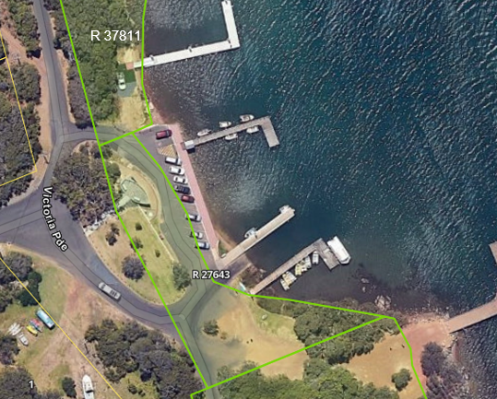
Sitemap 1: Ellis St Jetty Precinct – consisting of Reserves 37811 (Class A), 27643 (Class C)

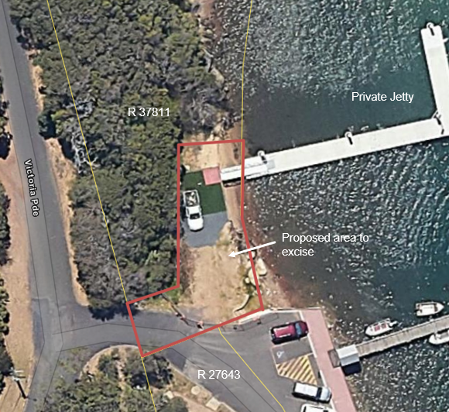
Sitemap 2: Proposed area to excise from Reserve 37811 and amalgamate with adjacent Reserve 27643

BACKGROUND
The Shire is the Management body for Reserves 37811 and 27643 that together comprise the bulk of the Ellis Street Jetty Precinct. Reserve 37811 is a Class A Reserve vested in the Shire for the purpose of ‘Recreation and Parkland’, while Reserve 27643 is a Class C Reserve, vested in the Shire for the purpose of ‘Recreation’. Class A reserves afford the greatest degree of protection for reserves of Crown land created under the Land Administration Act 1997 (LAA), and changes to the area or purpose of such reserves require a Ministerial order and tabling before parliament. The ‘A’ classification is generally used to protect areas of high conservation or high community value.

The Ellis St Precinct provides access to a number of jetties, one of which is a private jetty accessible via Reserve 37811. The portion of Reserve 37811, adjacent to the private jetty, is cleared of vegetation and does not contain any paths or public foreshore access, other than access to the private jetty. Previously, this site was used by a small boat and kayak business operating under a Local Law Permit issued by the Shire between 2014 to 2023. Although this portion is a part of the Class A Reserve 37811, it differs considerably from the remainder of the Class A reserve which is heavily vegetated with Paperbarks, Peppermints, Marris and other native shrubs.

Development Approval
The Applicant, owner of Blackwood River Houseboats, owns the private jetty located in the Class A reserve portion of the precinct, and holds a commercial jetty license issued by the Department of Transport (DOT). The Applicant was granted a development approval (DA) in January 2023, for the operation of a houseboat business and installation of power, water and sewer infrastructure to service the houseboats from the jetty.

At the time the DA was issued the Applicant had not requested exclusive use of the subject portion of the Reserve, nor was it obvious that the subject portion of the Reserve contained little to no public access to the foreshore beyond the private jetty. Accordingly the DA was not subject to the requirement to enter into a lease. However, based on the fact that the existing commercial jetty licence and the DA resulted in a practical exclusive use over that portion of the foreshore, Shire officers supported a request to lease as it was in the Shire’s interest to formalise this use to allow for the charging of rent and rates for the commercial use of Shire land. The request to lease has not been progressed due to the limitations of the Class A reserve and the proposed development application.

Installation of Jetty Infrastructure over Reserves
As part of the existing DA a Deed of Agreement has been drafted between the Shire and Applicant which conditions the installation and management arrangements of electricity, sewer and water infrastructure over various Shire Reserves, ongoing use of the infrastructure, and metering and associated billing for the electricity and water usage arrangements. The Deed of Agreement will continue in place until such time as a Crown Easement can be created for the Jetty Infrastructure through the Reserves. The Agreement will soon be finalised and executed.
Installation of the Jetty Infrastructure is substantially complete. The Applicant has also undertaken upgrades to the private jetty. The jetty infrastructure passes through the following Reserves:
- Reserve 37811
- Reserve 41047
- Reserve 27643
- Victoria Parade Road Reserve.

See Attachment 1 for site plan of jetty infrastructure.

Application for Amendment to Development Approval
On 24 July 2024, the Applicant applied for an amendment to their Development Approval. The proposal includes the establishment of an office and secured car parking on the portion of Reserve 37811 adjacent to private jetty, and permanently moored vessels (floating pod accommodation) at the private jetty to be used for short stay accommodation. The Applicant also requested to lease a portion of Reserve 37811 to locate the office and secured carparking.

The Shire has no delegated power to sign a development application under the Planning and Development Act 2005 as the owner of a Crown land Reserve vested to the Shire when the development is for a commercial purpose. As the proposed development consists of an office and secured carparking associated with the floating pod accommodation business, and is of a commercial purpose, it requires signing by the Minister for Lands, prior to assessment of the development application by the Shire.

STATUTORY AND POLICY REQUIREMENTS RELEVANT TO DECISION
Land Administration Act 1997 (LAA)
Section 42: Class A reserves, creating, changing etc.
If the Minister proposes to excise an area from a class A reserve, the Minister must advertise the proposal statewide, consult with the management body of the reserve and cause that proposal to be laid before each house of Parliament.

Section 18: Crown land transactions than need Minister’s approval
Section 18(2): A person must obtain prior approval in writing of the Minister, to grant a lease or licence, or sublease or sublicence under the Local Government Act 1995, in respect of Crown land in a managed reserve.

PREVIOUS RESOLUTIONS
Nil

STRATEGIC COMMUNITY PLAN 2040
Performance
Outcome PF.1: Responsible planning and ownership of outcomes
Strategy PF.1.4: Regulate and provide information and community communication in accordance with statutory requirements and to best support decision making

CONSULTATION AND ADVICE
External consultation
Shire officers met with Department of Planning, Lands and Heritage (DPLH) in September 2024 to discuss the process required to assess this application.

DPLH advised that as the Reserve 37811 is a Class A reserve, the development application will not be signed by the Minister for Lands in its current land tenure, as the proposed commercial development is not compatible with a Class A reserve with a designated purpose of ‘Recreation and Parklands’, and the Management Order will not be amended to grant the Shire power to lease. The subject portion of land would need to be excised from the Class A reserve and amalgamated with the neighbouring class C Reserve 27643, prior to the Minister for Lands signing the development application, or consenting to or entering into any lease arrangements.

In addition, both the waterway and Reserve 37811 are registered sites under the Aboriginal Heritage Act 1972 (AHA), and section 18 approval is likely required.

Councillors took part in a site visit to the portion of land proposed to be excised, at Ellis Street Jetty Precinct on 25 September, when attending a site visit on the Augusta Streetscape Plan.

Internal consultation
- Strategic Projects Officer
- Senior Environment Landcare Officer

The Senior Environment Landcare Officer provided the following comments in relation to the proposed excision:

Reserve 37811 (A class) extends along the foreshore of the Hardy Inlet. The Reserve, approximately 14,900 m2, contains intact riparian vegetation that protects and supports the waterway, and provides habitat for a range of native fauna, including species that are threatened or migratory. The vegetation comprises native rushes and sedges, saltwater paperbarks (Melaleuca cuticularis) at the water’s edge, Peppermints (Agonis flexuosa), Marri (Corymbia calophylla), and native shrubs.

The Shire’s Hardy Inlet Foreshore Management Plan (2014) describes the vegetation as being “in generally good condition and of considerable ecological value”. Retaining the vegetated portion of land near the private jetty, within the Class A Reserve ensures a continued high level of protection for this section of the Hardy Inlet riparian zone.

These comments are addressed toward the end of the ‘Discussion/Officer Comments’ section of this report.

DISCUSSION / OFFICER COMMENTS
Process of excision of a portion of Class A Reserve
The process required by the Shire to request the Minister for Lands to excise a portion of land from the Class A Reserve is outlined below. This process is governed by the State Government, under the Land Administration Act 1997.
- Shire undertakes community consultation on the proposal to request the Minister for Lands to excise a portion of Reserve 37811 (Class A) to amalgamate with the adjacent Reserve 27643 (Class C).
- Preparation of Council report for the consideration of submissions by Council prior to taking proposal to Minister for Lands.
- Survey of portion of land to be excised and creation of a Deposited Plan.
- Forward request to Minister for Lands.
- Minister for Lands is required to advertise statewide the proposed excision from A class reserve and cause the proposal to be laid before each House of Parliament (s42 LAA).
Next steps
- If the excision is approved, the Minister for Lands may then sign the development application for the proposed commercial use, as landowner.
- If Minister for Lands signs DA, then Shire can objectively assess the DA.
- If the DA is approved, preparation of Council report with recommendation to request DPLH to prepare a Crown land lease to the Shire over that portion of land, and Shire sub-lease that portion of land to the applicant.

It is anticipated this process will take a minimum of two years and this report relates to the first step. Much of the decision-making power within this process rests with the State Government. It is noted that this process will take a significant use of resources, for a private benefit.

The Applicant will also need to obtain advice from DPLH on whether further consents or approvals will be required under the Aboriginal Heritage Act 1972.

In regard to the easement over the jetty infrastructure, if the excision of land from the Class A Reserve and amalgamation into the Class C Reserve is approved, the Shire can then submit a request to Minister for Lands to grant an easement over the jetty infrastructure services. If it is not approved, and that portion of land remains in the Class A Reserve, the Shire can still request the granting of an easement, but the process is more complex, and requires the proposal to be put before both Houses of Parliament (s44 LAA).

Ellis Street Jetty Precinct
The Shire engaged in community consultation on a draft concept plan for Ellis Street Jetty Precinct in April 2023. Submissions were received, and the concept plan and submissions are expected to be presented to Council in the coming months. The draft concept plan identifies the subject portion of land as a commercial use zone (see Attachment 2), which is consistent with the proposal.

Amalgamating this portion of land with Reserve 27643 will create one foreshore reserve which extends across the Ellis Street Jetty Precinct. It also provides the opportunity for a realignment of the waterway boundary of Reserve 27643 to represent the correct boundary alignment, as currently the carparking area is situated within parcel of land designated ‘waterway UCL’.

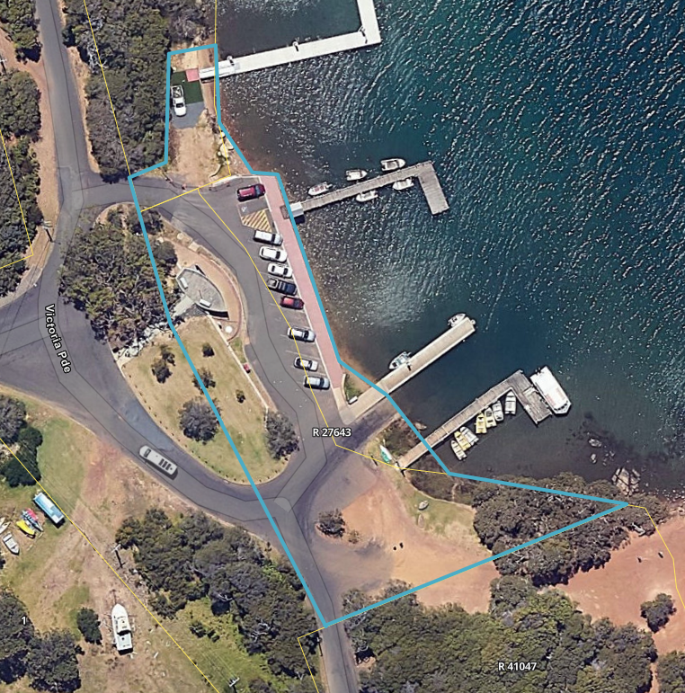
Sitemap 2: Proposed amalgamated Reserve 27643 with realigned waterway boundary

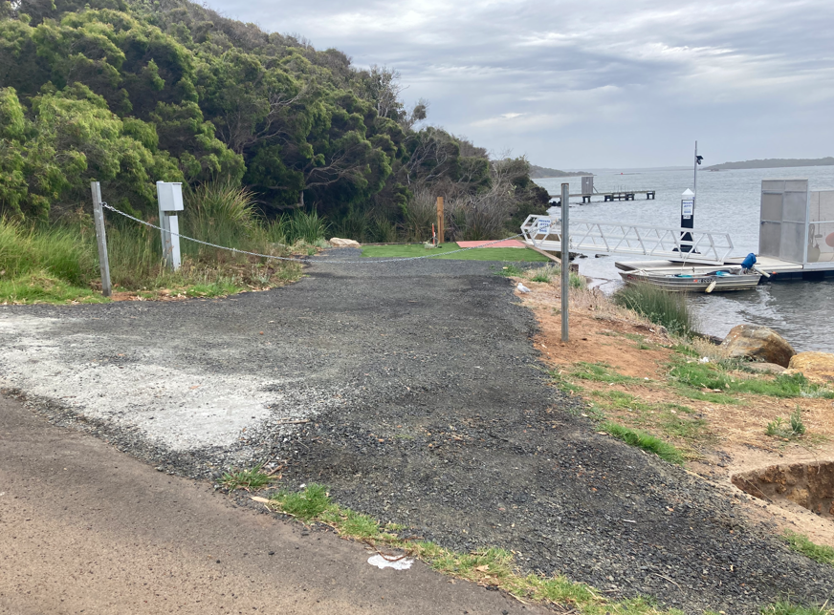
Site Map 3: Proposed area to excise which provides access to the private jetty

The proposed excision area is approximately 300 m2 and consists of part road, dirt and gravel and provides access to the private jetty.

Given that the subject portion of land is cleared land, was previously utilised by a commercial boat and kayak business, and provides access to a commercially operated private jetty, it is recommended that Council undertake the first step in the process to engage in community consultation on the proposal to request Minister for Lands to excise the portion of Reserve 37811 (Class A) to be amalgamated with adjacent Reserve 27643 (Class C).

The proposal provides that the native vegetation component of site would remain within the Class A Reserve to ensure a continued high level of protection, which is consistent with comments from the Senior Environment Landcare Officer, ‘Retaining the vegetated portion of Reserve 37811 within the Class A Reserve will ensure a continued high level of protection for this section of the Hardy Inlet riparian zone’.

Furthermore, amalgamating the portion of land with Reserve 27643 will create one Shire managed foreshore reserve extending across the Ellis Street Jetty Precinct, a realigned foreshore/waterway boundary and an appropriate land tenure which will enable consideration of the applicant’s proposal.

The recommendation in this report relates to the first step in the process, and does not provide consent or approval to any of the further steps such as the amended development application This will require an objective assessment under the Shire’s Planning Scheme.

FINANCIAL IMPLICATIONS
Implications, Long Term Financial Plan, Whole of Life Cycle Considerations
The applicant will be responsible for:
- costs of installation and maintenance of the jetty infrastructure.
- costs of surveying the land to be excised and amalgamated and the creation of a deposited plan.
- survey costs and preparation of legal documents related to granting of the easement.
- survey costs of lease area, and preparation of lease documents.

If the proposal is ultimately supported, and the Shire enters into a lease agreement with the applicant, the Shire will receive commercial rent for the leased area, at a negotiated rate, based on an independent market rent valuation.

SUSTAINABILITY IMPLICATIONS
Environmental, Social, Economic, Contribution to ‘Net Zero’ Targets
The portion of Class A reserve proposed to be excised is approximately 300m2. Class A reserves offer the highest level of protection under the LAA, designed to preserve areas with high conservation, or recreational values. Changing to a Class C reserve will lower this level of protection. However regardless of the class, due to the location of the private jetty this portion of land will still be used almost exclusively as an access path to the private commercial jetty.

ADVOCACY
This process to request the Minister for Lands to excise a portion of land from the Class A Reserve 37811 will ultimately require the Shire to form a position on whether they support the excision or not, and forward their feedback to the Minister for Lands under section 42(6) LAA. However, this first Council report only deals with the decision to engage in community consultation.

RISK ASSESSMENT
The risks associated with Council deciding not to engage in community consultation on the proposal to request an excision of the portion of Reserve 37811, will ultimately prevent this portion of land from being used for a commercial purpose, and the portion of land will remain within the Class A Reserve. However, regardless of the land tenure, the portion of land will still be used to access the private jetty, which operates a commercial business.

The risks associated with supporting the officer’s recommendation are minimal, as the recommendation involves engaging in community consultation on the proposal. Following the consultation period, a report will be prepared for Council to consider the feedback received and decide whether to request the Minister for Lands to excise a portion of Reserve 37811 (Class A) to be amalgamated with the adjacent Reserve 27643 (Class C).

OFFICER RECOMMENDATION / COUNCIL DECISION
CR EARL, CR D’ATH OM2025/18
That Council requests that the CEO undertake community consultation on the proposed request to the Minister for Lands to excise the portion of Reserve 37811 (Class A) delineated in red in Sitemap 2, to amalgamate with the adjacent Reserve 27643 (Class C).

CARRIED 7/0
FOR: CRS BINKS, BOLAND, D’ATH, EARL, JONES, KENNAUGH, MUIR
AGAINST: NIL

