Access and Inclusion Plan
2023 – 2027

DRAFT DOCUMENT
To be professionally designed.

Alternative formats (confirm with the Centre for Accessibility)
The information in this document is available in alternative formats, including large print, audio, braille, or electronically by email.

Please contact the Shire’s Community Development Team at communitydevelopment@amrshire.wa.gov.au or visit the Shires website at www.amrshire.wa.gov.au.

Language assistance
The Shire of Augusta Margaret River is home to many people from across the world, who have access to our assistance for non-English speaking residents.

Translation services for 160 languagues are available through the Translating and Interpreting Service (TIS).

To use this service, please phone TIS on 13 14 50 or ask the Shire of Augsta Margaret River’s customer service team for assistance.

The National Relay Service (NRS)

The NRS can contact the Shire of Augusta Margaret River on your behalf:
- TTY/voice calls 133 677
- Speak and Listen 1300 555 727
- SMS relay 0423 677 767

Welcome to Wadandi Boodja

“Kaya, Nala Maat Kaya Noonduk (Hello, Our Family Welcomes You) to Wadandi Boodja (Saltwater People’s Country) – we all come together on Boodja (Country). Whilst on Wadandi Boodja we ask that you respect the land by walking softly and take the time to listen to Boodja as she Wongi (Talks).

We respect the presence of the Demmala Goomala (Ancestors) whose Djanga (Spirits) reside on Boodja and whose Djenna (feet) walk the land and whose Djanga Korda (heart spirit) flows through all creation.
Wooditjup (Margaret River) is the heart of Wadandi Boodja (country), a meeting
place between land and sea, connecting us all with Wadandi Boodja.

The Wadandi Boodja (Motherland) reaches from Bunbury, along the coast of Geographe Bay, extending to Yallingup (Place of Holes) to Talinup, Augusta (Place of Reeds) inland to Nannup (The Stopping Place), taking in the region of Undalup (Busselton) The Wadan Boodja (Sea Country) is of great spiritual significance to the coastal Wadandi people.

Boodja – Land, Country, Mother Earth – is our most important resource. No matter what culture or religion – all of us rely on Nala Boodja, Our Country.

It is up to all of us to listen to the land, understand the connection to Country that we all have and realise how urgent it is to work together to make better decisions on how we can create that balance, ensuring sustainability for the generations to come, in order to protect and preserve the beauty of Boodja.
Whilst living, travelling, visiting and holidaying on Wadandi Boodja (Saltwater People’s Country) we ask that you respect the area and walk softly on the country, taking the time to listen to Boodja (Country) as she Wongi (Talks) of the Season, and leave nothing but footprints”.
Wadandi Traditional Cultural Custodian Wayne “Wonitji” Webb.

Acknowledgement of Country

The Shire of Augusta Margaret River acknowledges we are on Wadandi and Pibelmen Boodja, whose ancestors and their descendants are the traditional owners of this country.
We acknowledge the Wadandi and Pibelmen have been custodians since the land was soft (creation times) and continue to perform age old ceremonies of celebration, initiation and renewal. We acknowledge their living culture and their unique role in the life of this region.
The Shire is committed to Aboriginal Australians sharing fairly and equitably in the region’s cultural, social, environmental and economic future.

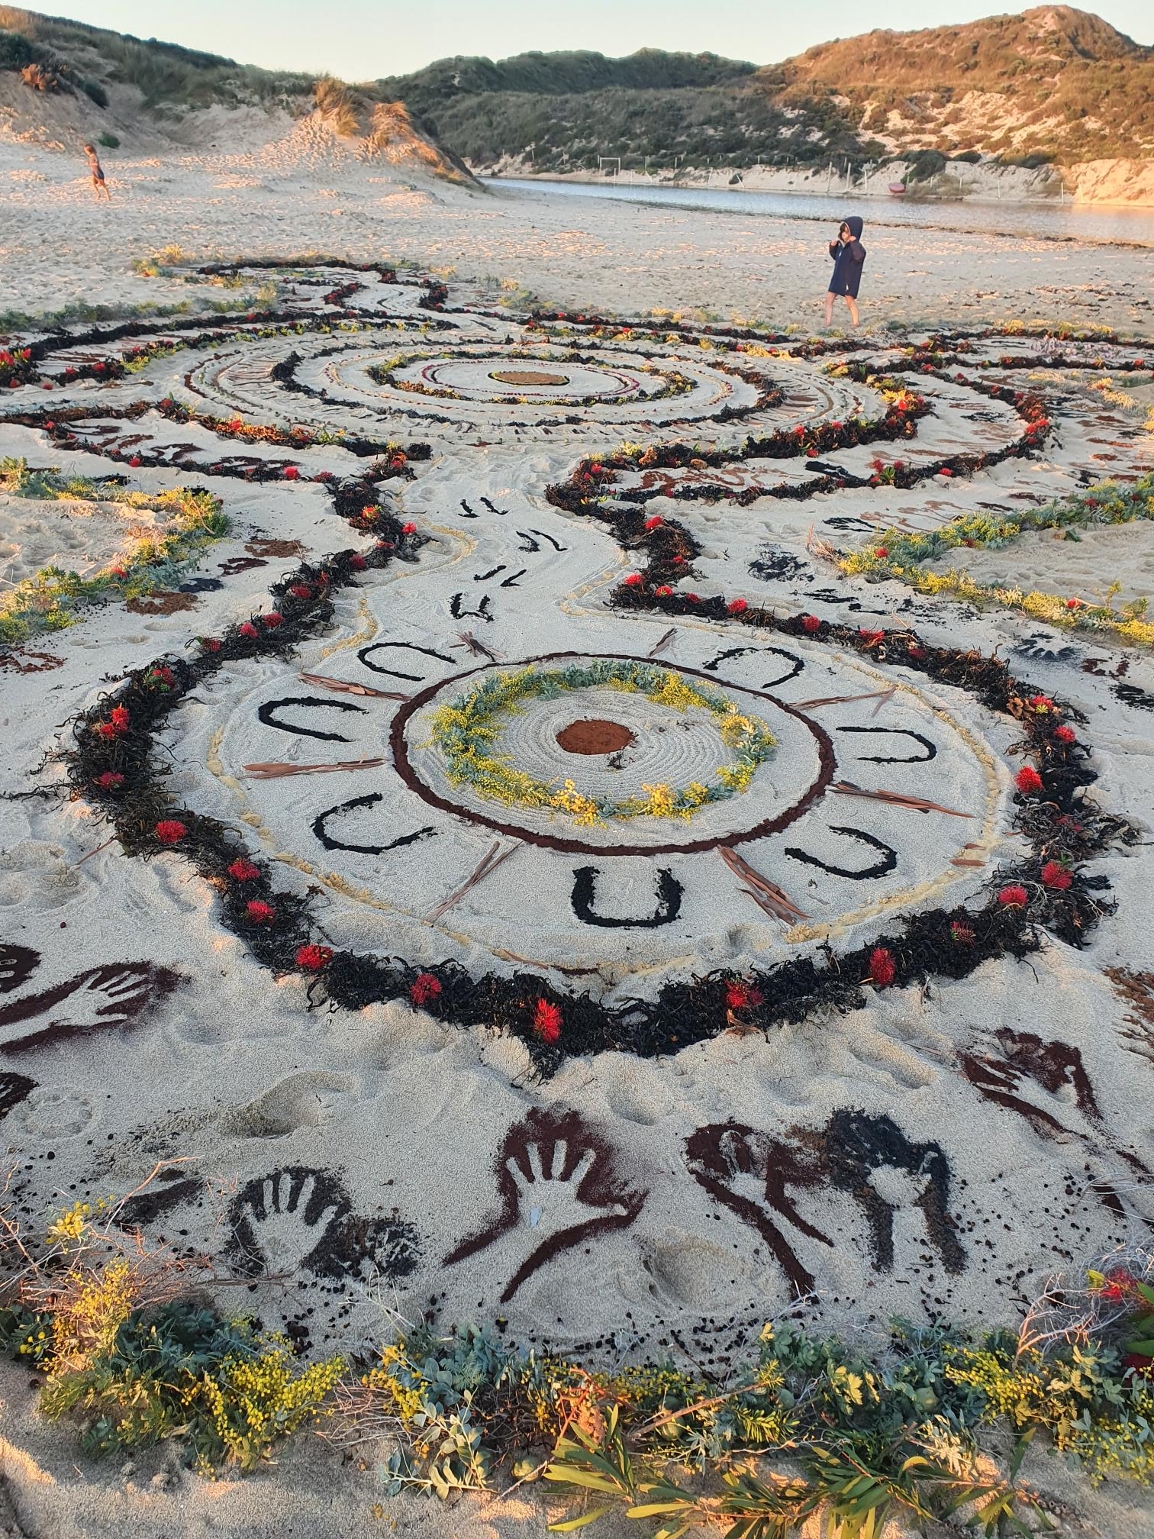
As part of NAIDOC Week 2022 community members joined Wardandi Matriarch Vivian Brockman, Mitchella Hutchins and artist Elaine Clocherty to build a natural land art piece around the ‘Bora’. Centred around djanga coombart 'family spirit'.
Forward

We’re delighted to share with you the Shire of Augusta Margaret River’s 2023 - 2027
Access and Inclusion Plan.

This plan outlines the actions we’ll be taking over the next five years to improve access and build more welcoming and vibrant communities throughout our shire.

The strategies within this plan have been developed in consultation with the community by connecting with people from all walks of life. They seek to build on past achievements to deliver meaningful and tangible outcomes in the future.

Responsibility for implementing this plan extends across the whole organisation. From communications, human resources, and administration, to buildings, parks and facilities, all Shire officers play an integral role in improving access and inclusion outcomes.

The Shire of Augusta Margaret River is widely recognised as a leader in access and inclusion, and we’re proud to have been the winner of the MACWA Award for the most accessible region for all of the four years it has been awarded. However, we know that there’s more work to be done.

With a commitment to working in collaboration with the community, we’re confident that the Shire will continue to celebrate diversity, drive sustainable change, and build more inclusive communities that can be enjoyed by everyone.

We look forward to sharing the achievements of this Plan at the end of each year of its implementation.

Paula Cristoffanini, President of the Shire of Augusta Margaret River
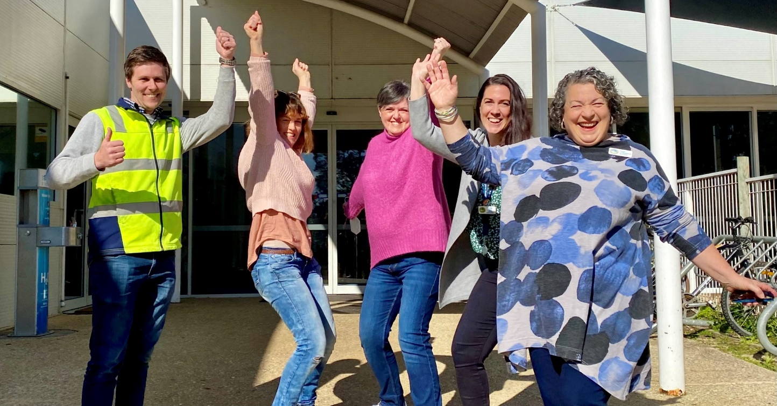
Shire President, Paula Cristoffanini (far right) celebrates the announcement of grant funding for the construction of the region’s first certified Changing Places adult change facility at the Margaret River Recreation Centre, opening 2023.

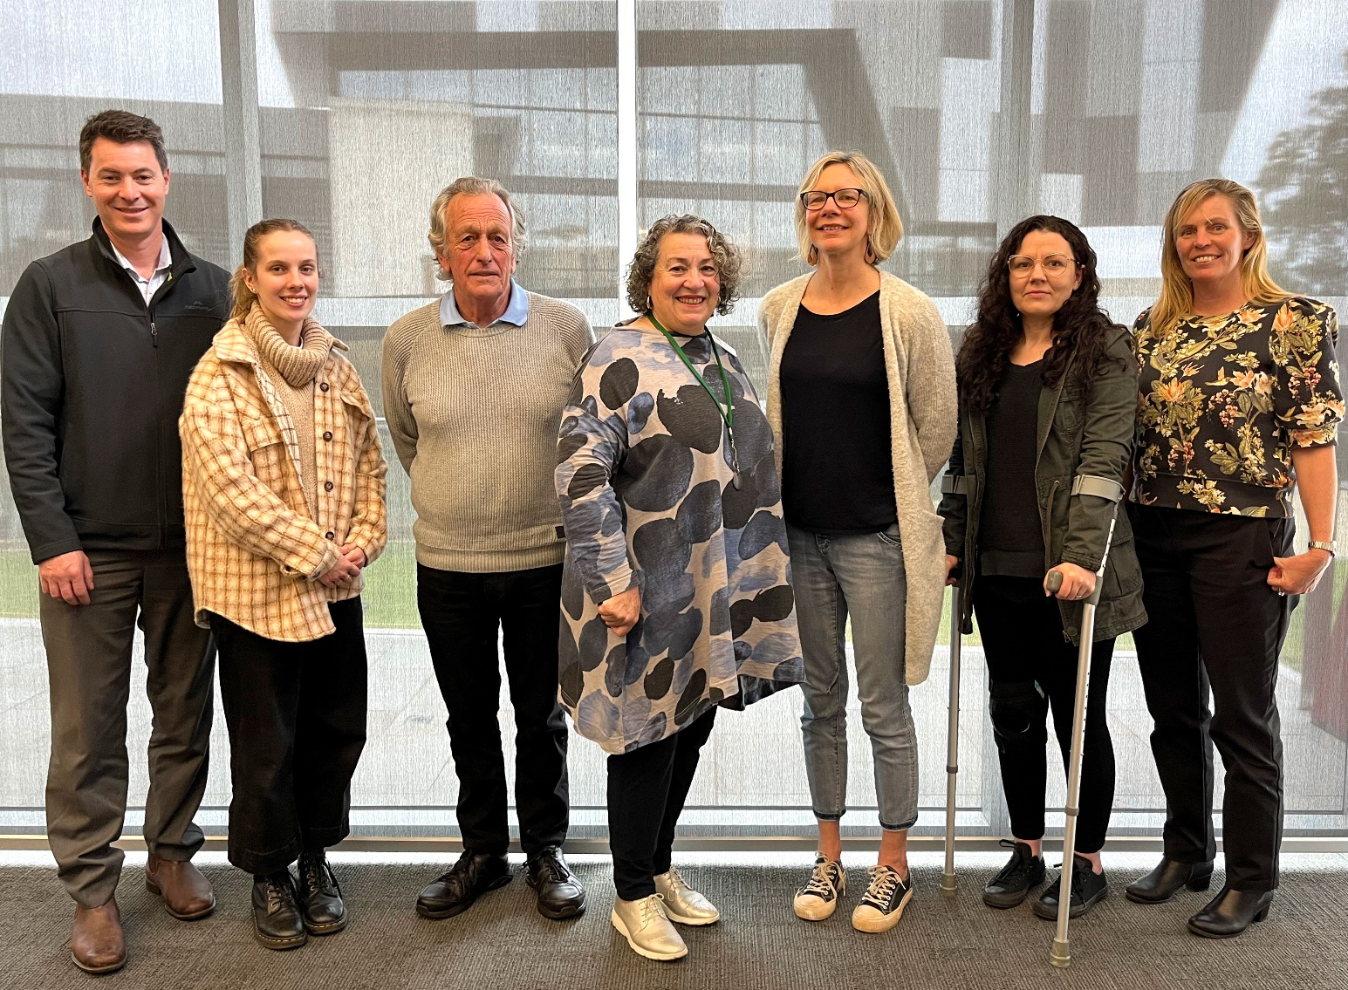
Shire President, Paula Cristoffanini with the members of the Access and Inclusion Plan Working Group.
L-R Matthew Wittorff (Enable WA), Shannon Walker (AMRSC), Anthony Pursell (Disabled Surfing WA), Paula Cristoffanini (AMRSC), Danelle Milward (Therapy Focus), Melinda Thomas (community member) and Rebecca Young (AMRSC). Absent – Stephen Beddington (community member).

Thank you!
We would like to acknowledge every person who contributed to the development of this Plan by sharing their knowledge, insights and lived experiences.
Special thanks are also given to the members of the Access and Inclusion Plan Working Group, who worked closely with us through every step of the Plan’s development. We are both grateful and thankful for their commitment, expertise, and guidance.

Contents
Why is this Plan important? 7
What is Access? 7
What is Inclusion? 7
What is the purpose of this Plan? 7
How did we develop this Plan? 8
Our Plans 10
Outcome one: Events and services 10
Outcome two: Buildings and facilities 12
Outcome three: Information 14
Outcome four: Quality of service 16
Outcome five: Opportunities to provide feedback 17
Outcome six: Public consultation 18
Outcome seven: Employment 19
Outcome eight: Capacity building 20
Our Commitment 21
How will we implement this Plan? 21
How does the Plan support the Shire’s strategic goals? 23
Document control 25

What is Access and Inclusion?

Access
Access means that everybody can enjoy our public places, facilities, and natural environments. This includes buildings, recreational and leisure facilities, public amenities, footpaths, parks, playgrounds, nature trails and beaches, along with access to information, services, events and employment.
In accessible communities, people with disabilities can actively contribute and thrive.

Inclusion
Inclusion means that everyone is welcomed in a connected community that values the differences in all people and celebrates them for exactly who they are.
In inclusive communities everybody belongs.
What is the purpose of this Plan?

The purpose of this Plan is to identify and implement strategies across the organisation that deliver access and inclusion outcomes throughout the region, to enhance the lives of everyone.
A community that recognises its diversity and supports the contributions of all its members makes for a richer community life.

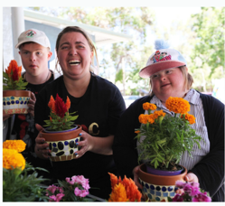
Local community group Artzability Inc gift handmade mosaic flowerpots to the nominees of the Shire’s annual Volunteer of the Year Awards.

How did we develop this Plan?

This Plan was developed in close consultation with an Access and Inclusion Plan Working Group, representing the Shire’s broader Community Access and Inclusion Reference Group (CAIRG).

Following initial meetings with the Working Group and the development of a Community Engagement Plan, a community survey was open to all members of the public from April 30 to June 10, 2022.

The survey was promoted through several channels:

- The CAIRG and other Shire community networks.
- Newspaper advertisements in the Augusta Margaret River Times and Augusta Pelican Post.
- A series of social media posts published on the Shire’s Facebook page involving the use of both photographs and video content.
- Posters, flyers and hard copy surveys displayed in Shire facilities, such as the Library, Recreation Centre and Margaret River HEART.
- An interview with the Shire President on Radio Margaret River.
- Email campaigns to Shire networks and community e-newsletters.
- Direct emails or telephone contact with primary stakeholders.
- Promotion on the Shire’s Your Say website.
- Distribution to all Shire staff.

Due to Covid-19 concerns during the consultation period, instead of hosting large community workshops, Shire officers consulted with community members at small existing events where people felt safe and comfortable. These events included:

- A Shire hosted lunch with members of Artzability, staff and carers, following an Artzability workshop at the Margaret River HEART.
- Morning Tea with the audience of Young@HEART, following a weekly music performance for seniors.
- Consultation with the Youth Advisory Committee at their weekly group meetings.
- Survey distribution and update at an Advocacy WA Business Workshop, hosted at the Shire of Augusta Margaret River.
- Survey distribution and consultation at the Shire hosted National Volunteer Week Big Breakfast.

The Shire was delighted to receive 90 completed Access and Inclusion community surveys.

32 surveys were received as hard copies and 58 surveys were completed online via the Your Say website.
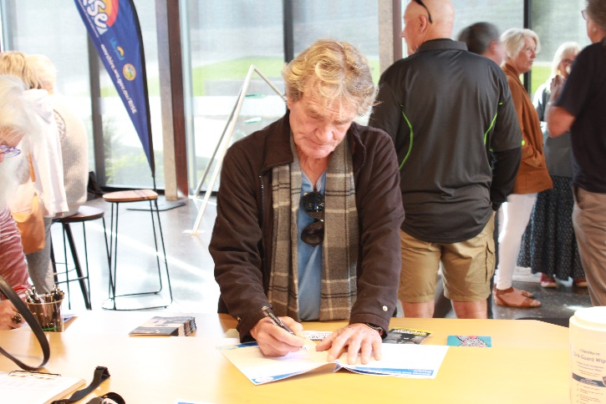
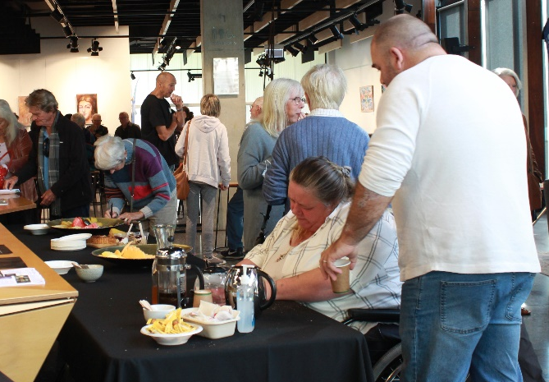

Community members complete surveys at the 2022 National Volunteer Week Big Breakfast

Background of responders:

- One third of responders were people living with disability, carers of people with disability or disability service providers.

- 68 people identified as female, 19 people identified as male, and 3 people identified as non-binary.

- 68 people were Australian, 2 people were Aboriginal Australians and 19 people were from culturally and linguistically diverse backgrounds.

- 58 people lived in Margaret River, 25 people lived in other towns within the shire, and 7 people resided outside of the shire.

- Two thirds of responders were employed in full time or part time employment. 17% of responders participated in volunteering.

- The ages of responders were evenly distributed, ranging from youth to over 75.

Shire Officers also engaged in ongoing consultation with colleagues and Council.

Community demographics (to be updated)

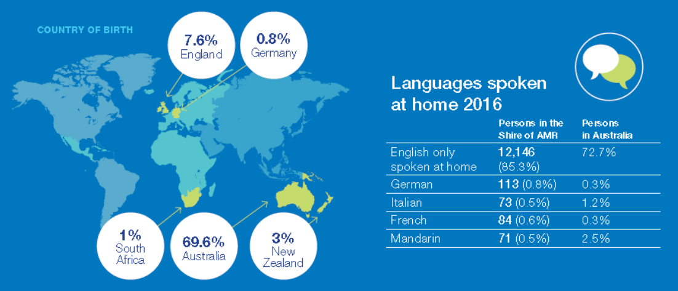

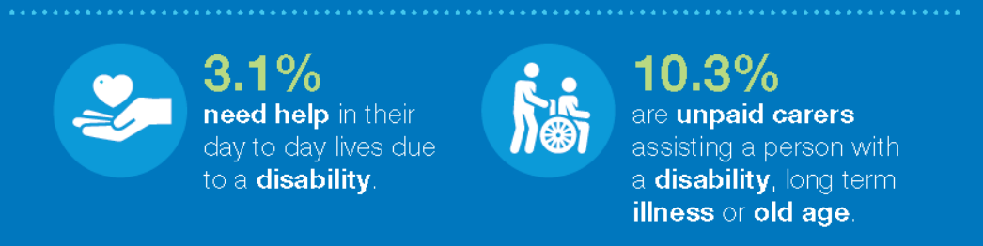

Population 16,172
401 people
in the Shire need assistance in their day-to-day lives due to disability.

The proportion of people who experience discrimination was the same for the people in the shire (21%) as in Western Australia and slightly higher than Australia (19%).
SEIFA Index of Disadvantage
Shire - 1025
WA - 1016

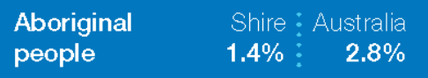


9.2% in the Shire provide unpaid care to a person with a disability, long term illness or old age.
Sources: ABS ERP 2016, SEIFA Index, Mental Health and Wellbeing in the Shire of Augusta Margaret River (Lishman Health Foundation)

What we heard – examples of the community’s feedback:

“My elderly mother feels some places in town are only for those able to walk up steps, which I feel is sad because as the business centre changes, she doesn’t get to see the new shops and cafes”

“People assume I can access everything because I’m good at hiding my disability.”

“Make spaces for quiet or calm so I can regulate and then join in again.”

“Make space for carers to attend events and advertise the fact that they’re welcome. Make sure there is plenty of seating at outdoor events with close parking or drop off points.”

“I would like to see more inclusion of Noongar history and culture.”

“Be aware that not all can use or have access to computers.”

“More employment opportunities for people with other abilities so we can all work together.

“We moved here a year ago and started volunteering at the HEART. We’ve been made welcome from the start, and it certainly helped us get involved in the community straight away.”

“Just treat everyone the same regardless”

Access and Inclusion Plan 2023 – 2027
Outcomes and Strategies

The following strategies have been developed in response to community feedback to deliver tangible and meaningful actions across eight key outcome areas.

Outcome One: Events and services
Outcome two: Buildings and facilities
Outcome three: Accessible information
Outcome four: Quality of service
Outcome five: Feedback opportunities
Outcome six: Public consultation
Outcome seven: Employment
Outcome eight: Capacity building

The Shire of Augusta Margaret River’s Access and Inclusion Plan is a requirement of the Western Australian Disability Services Act 1993 (amended 2004). The Act states that public authorities must review their access and inclusion plans at a minimum of every five years.
Outcome one: Events and services
Vision: Vibrant, welcoming, connected communities.
Mission: To improve accessibility and inclusiveness of community events and services.

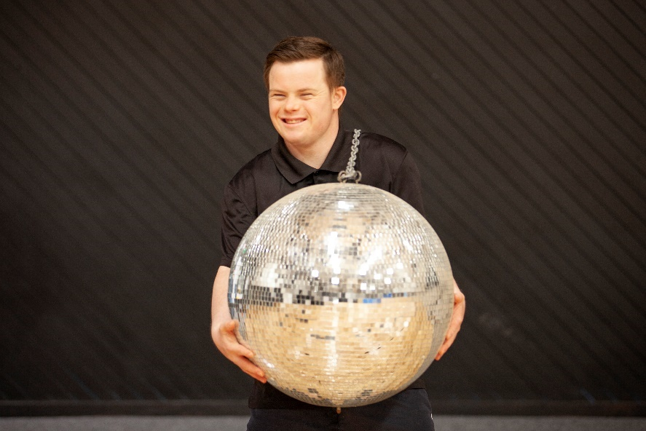
Example: Shire employee Beau prepares for the Rec Centre’s annual International Day of People with Disability (IDPwD) Disco. This free, fun and accessible event encourages everyone to get their groove on and celebrate.

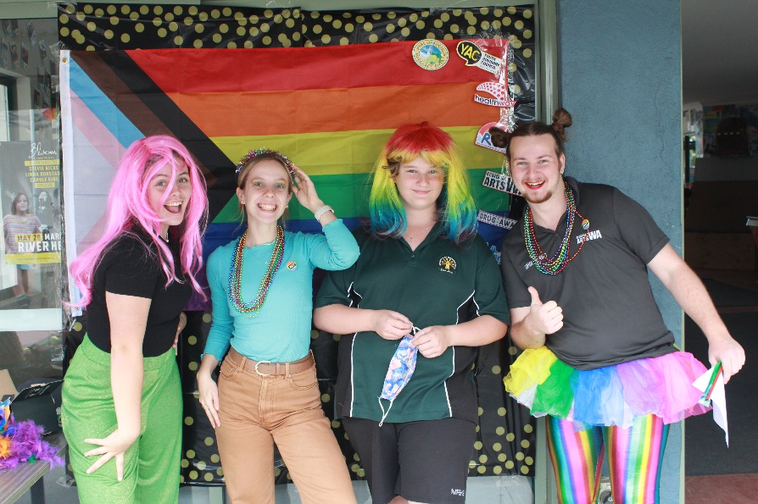
Example: The Shire’s Loud and Proud Youth Week events celebrated our LGBTQIA+ community in partnership with newly funded grass roots local organisation, Margi Pride Inc.

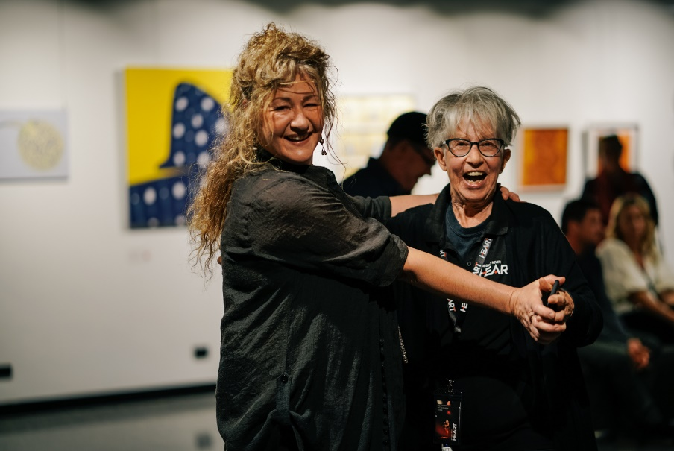
Example: The Shire’s Volunteer with HEART program allows everyone to engage in events, get behind the scenes and connect with like-minded art lovers.
Volunteers play an important role in bringing events to our community and are valued members of the HEART team.
What did we hear?
Consultation with the community highlighted the importance of participating in diverse and inclusive community events, volunteer opportunities, and local community groups.

Priority strategies:

Deliver annual events that celebrate our diverse and vibrant communities
Key actions:
- Plan, promote and support events that celebrate diversity within our community.
- Engage the community in a diverse events program.

Improve inclusion at Shire led events
Key actions:
- Conduct an audit of parking and drop off bays at Shire venues.
- Conduct an independent review of the Shire’s Inclusive Events Checklist.
- Encourage substantial lead time on the promotion of any Shire event to allow for attendee arrangements such as transport and carers.
- Promote opportunities for carers to attend events and provide complimentary tickets.

Encourage inclusion at community led events
Key actions:
- Review and update the Shire’s event permit application forms, to weave the principles of inclusion throughout the document.
- Develop and supply an inclusive events toolkit to all event permits and grant recipients.
- Develop and supply a marketing and promotion toolkit to all event permit holders and grant recipients
- Encourage events to be held at locations that offer accessible facilities and pathways and highlight where improvements are being made.

Strengthen volunteerism and community groups
Key actions:
- Promote volunteering opportunities with the Shire of Augusta Margaret River.
- Promote and support volunteer opportunities within the region.
Continuing strategies:
- Effective internal planning to incorporate diversity, access, and inclusion.
- Applicants to consider diversity, access and inclusion when requesting Shire funding for community initiatives.
- All contracted services to adhere to access and inclusion requirements where possible.
- Continue to develop and deliver programs, initiatives and services that are equitable, accessible, and inclusive.
- Advocate for accessible services in the community.

Outcome two: Buildings and facilities

Vision: Accessible places and spaces enjoyed by everyone.
Mission: To improve access to Shire buildings and public spaces.

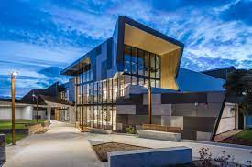
Example: Thanks to the CAIRG’s involvement in the planning, the Shire’s Hub for Entertainment, Art and Regional Tourism (HEART) is a flagship example of an accessible building, including automatic entry doors, accessible unisex bathrooms, tactile and braille signage, a wheelchair lift to the main stage, and more.

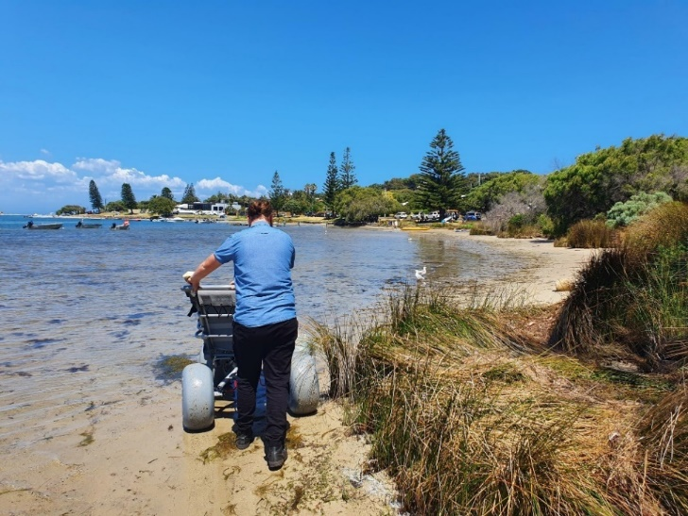
Example: A new Surf n Turf beach wheelchair is available for free loan from Turner Holiday Park in Augusta, providing wheelchair users with access to natural environments, such as sand or bush tracks and shallow entry into fresh or salt water.

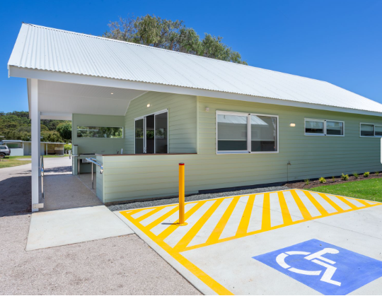
Example: Accessibility at the Shire’s Turner Holiday Park has been improved with the addition of a universally accessible chalet and upgraded all-access toilet and shower unit to one of the amenity blocks.

What did we hear?
Improving access at local beaches was the strongest request from our community, followed by upgrades to pathways and road crossings, play spaces, sporting fields and public amenities including non-gender specific signage.

Priority strategies:

Improve access to beaches throughout the region
Key actions:
- Determine the scope for improvements to beach and water access at Flinders Bay, Augusta.
- Conduct an independent accessibility analysis of swimming locations around Prevelly, Gnarabup and Gracetown, to determine whether these beaches are suitable for access upgrades.
- Consider prioritisation of accessibility upgrades at suitable locations subject to the analysis, including whether additional beach wheelchairs are required in the region to support this access.

Safe and accessible pathways and pedestrian crossings
Key actions:
- Upgrade pathways within the centre of the Margaret River townsite.
- Install a pathway connection between Witchcliffe town centre and Redgate Reserve.
- Improve pedestrian access and implement traffic calming strategies around the River Precinct (Rotary Park and Old Settlement) in Margaret River.

Accessible play spaces and sporting fields
Key actions:
- Implement designs for accessible play spaces at Riflebutts Reserve, Prevelly, and consider within playground renewals.
- Review and improve the connectivity of pathways at Gloucester Park.
- Consider accessibility as part of all future play space upgrades including Cowaramup play spaces.
- Consideration of gated playgrounds in future play space upgrades.

Upgraded public amenities
Key actions:
- Complete the construction of a certified Changing Places facility at the Margaret River Recreation Centre.
- Progress upgrades or renewal of public amenities throughout the region incorporating universal accessibility within designs.
- Consideration of adult change tables in public amenity upgrades within Shire facilities where staff are present.
- Consideration of gender appropriate signage in accordance with the public amenities program.
Continuing strategies:
- All new or redeveloped Shire facilities to support a universally accessible community.
- Accessible parking bays in the shire are of a high standard and used appropriately.
- All contractors work in accordance with the Shire’s access and inclusion plan.
- Tactile Ground Surface Indicators (TGSIs) in the shire comply with current standards.
- Encourage developers of non-Shire buildings to consider access and inclusion through application processes and approvals.

Outcome three: Accessible information

Vision: Informed, engaged, involved communities.
Mission: To improve access to information for all community members.

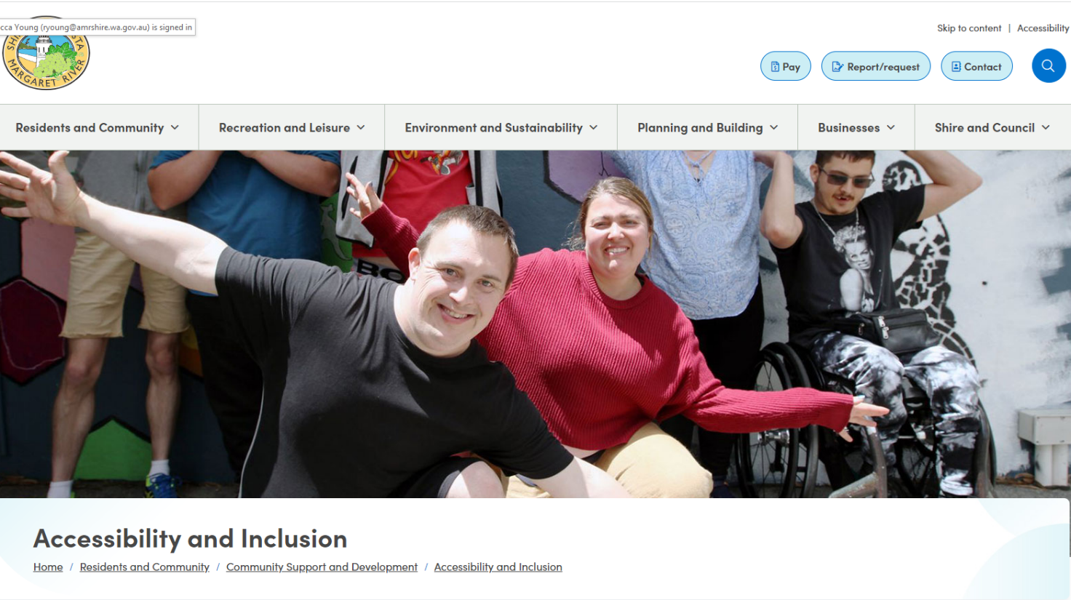
Example: The Shire’s newly launched website has been built to comply with WCAG 2.1 Level AA standard of accessibility and should be easily navigable for anyone using assistive technologies.

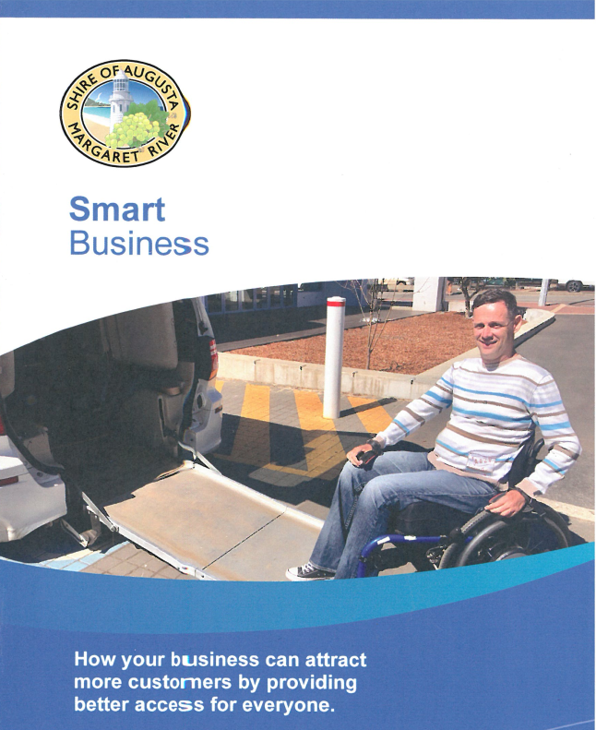
Example: The Smart Business booklet provides information on how to attract more customers by providing better access for everyone.
What did we hear?
Over one third of people consulted do not find it easy to access information in the shire. Requests included enhancing the promotion of events, accessible icons, hard copy materials and an Instagram page, along with greater inclusion of Wadandi Pibelmen history and culture.

Priority strategies:

Enhance the promotion of Shire and community led events
Key actions:
- Develop and supply community event organisers with an information pack on event marketing and promotion.
- Strive for widespread and early promotion of Shire led events and activities.
- Investigate methods to promote events and opportunities to the wider public through displays of information.
- Review the Shire’s use of social media platforms.

Improve information on accessible facilities within Shire
Key actions:
- Review and supply information on accessibility features in all Shire facilities.
- Provide greater online information on accessible places, spaces and facilities in the shire via the website, to support the local community and accessible tourism.
- Review the use of accessible icons on Shire signage and communications.

Provide greater information on Wadandi history, culture, and language, in line with the Shire’s Walking Together Plan
Key actions:
- Celebrate NAIDOC Week and local Wadandi driven festivals and events.
- Share Wadandi heritage of the region via naming and interpretative signage.
- Engage Wadandi stories and visual arts within the Shire’s public art collection, libraries, historical societies and other appropriate places.

Continuing strategies:
- All Shire information is available in alternative formats upon request.
- Shire marking is consistent with accessibility standards for information.
- Shire communications and information regarding services, facilities and feedback is in an appropriate format using clear and concise language.
- Maintain information on the website and in accessible formats

Outcome four: Quality of service

Vision: All Shire customers are welcomed, supported, and valued.
Mission: To strengthen the quality of service delivered by Shire staff.

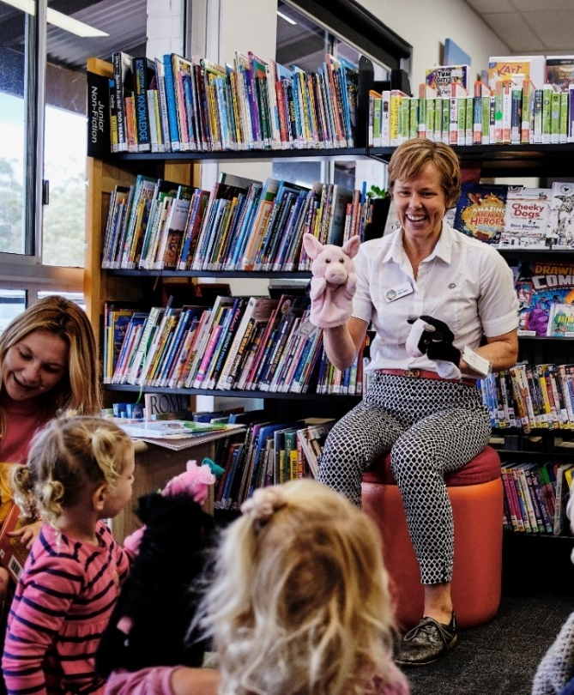
Example: In recent years the Library has enhanced their services to include a c-pen, large dyslexia friendly book range for both adults and juniors, Auslan chat group, digital assistance workshops for seniors, large font book range, quiet spaces and sensory zones, and a Uno Club for young adults with disabilities and their carers.

What did we hear?
While three quarters of community members consulted felt supported by Shire staff, one quarter felt only somewhat supported. Areas for improvement included consideration of invisible disabilities, language barriers, elderly customers, and customer privacy.

Priority strategies:

Enhance understanding, knowledge, and skills of Shire employees
Example actions:
- Provide ongoing training and education opportunities for staff at all levels.
- Review and update the staff Access and Inclusion Inductions.

Improve the customer’s experience in Shire facilities
Key actions:
- Investigate the feasibility of a private space at the administration front counter.
- Investigate ways to improve comfort for elderly customers such as seating in queues.

Continuing strategies:
- All Shire staff to undergo comprehensive access and inclusion inductions.
- Information and resources on access and inclusion are readily available to staff.
- Promote the Shire’s achievements regarding access and inclusion to all employees.

Outcome five: Opportunities for feedback
Vision: All community members are empowered to provide feedback.
Mission: To ensure that all people have the same opportunity to provide feedback or make complaints.

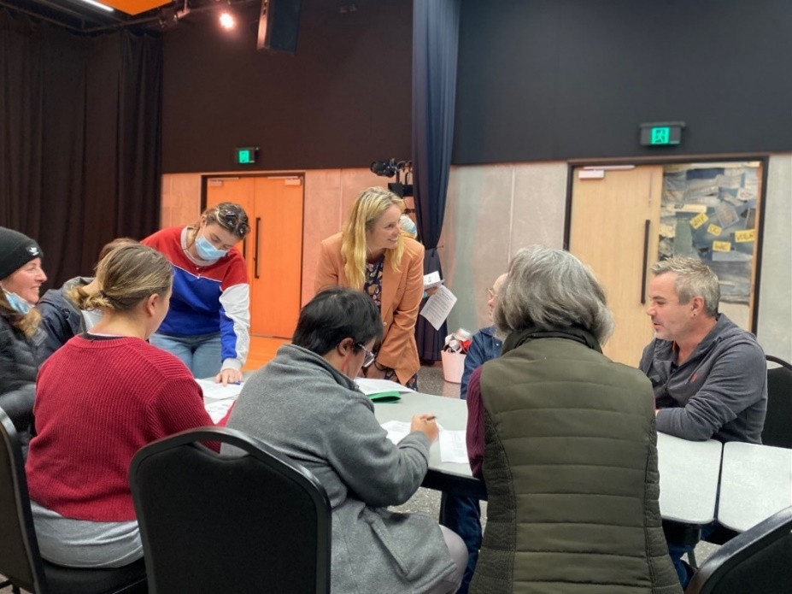
Example: Shire officers and CAIRG members consult with the participants of Artzability to hear their thoughts and experiences of inclusion in the shire.

What did we hear?
Improving response rates to customer queries, phone calls and emails was noted by the community, along with enhancing communication skills to encourage community members to feel comfortable expressing feedback.

Priority strategy:
Improve response rates to queries and complaints.
Key actions:
- Improve staff communications to encourage community feedback.
- Strengthen staff knowledge of complaints procedures.
- Review the Shire’s complaints procedure and customer service charter.
- Actively engage with people with disability to obtain feedback on a regular basis.
- Encourage the use of Google Translate to overcome language barriers.

Continuing strategies:
- Promote and encourage feedback through the Shire’s Your Say website.
- Grievance mechanisms are accessible for all our community.
- Monitor complaints and feedback received to identify areas for improving accessibility.

Outcome six: Public consultation
Vision: An active and esteemed community and Community Access and Inclusion Reference Group (CAIRG)
Mission: To improve opportunities for all our community to participate in public consultation undertaken by the Shire.

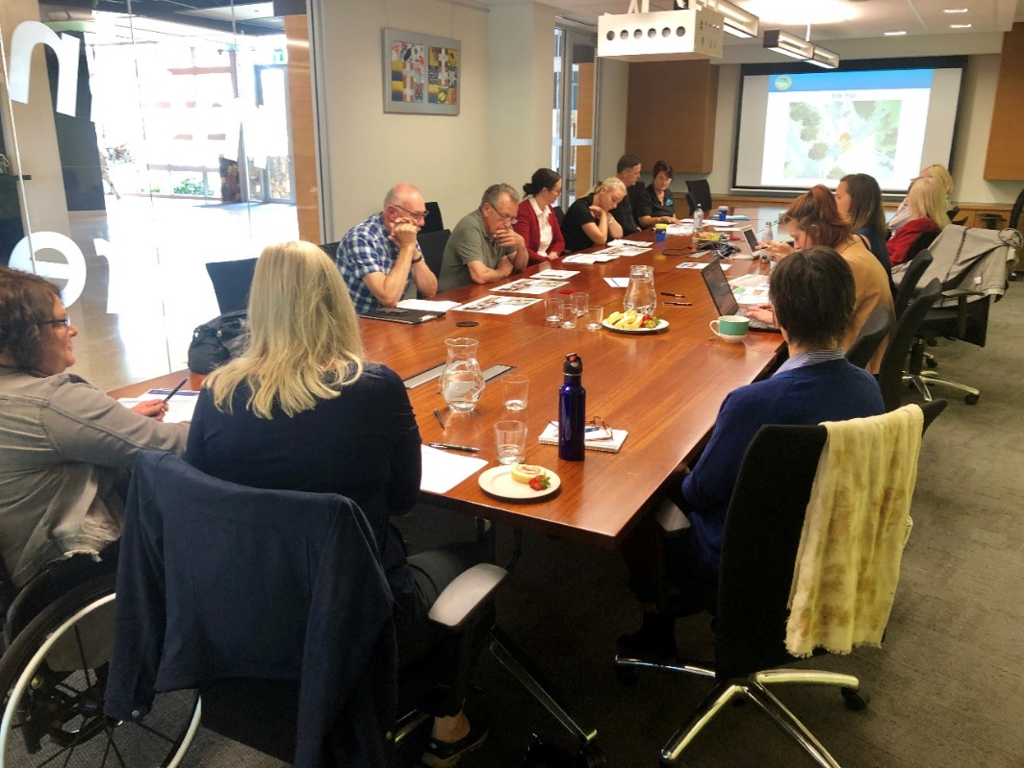
Example: Members of the Shire’s Community Access and Inclusion Reference Group discuss Shire plans and activities at a quarterly meeting.

What did we hear?
Two thirds of community members consulted were not aware of the Shire’s Access and Inclusion Reference Group.

Priority strategy:

Strengthen the Community Access and Inclusion Reference Group (CAIRG)
Key actions:
- Ensure representation of people living with all abilities on the CAIRG.
- Refresh the CAIRG including a new, more inclusive name.
- Enhance the promotion of the role of the CAIRG and opportunities for involvement.
- Welcome new members to the CAIRG with adequate support and information.
- Ensure all CAIRG members feel involved and valued for their contributions.
- Promote opportunities for people outside the organisation to consult with the CAIRG.
Continuing strategies:
- People of all backgrounds and abilities in our community can comment on facilities, services, events, strategies, policies and plans.
- Diverse representation of our community on all Shire Committees.

Outcome seven: Employment
Vision: A dynamic and diverse workforce that welcomes everybody.
Mission: To improve employment opportunities for all people to obtain and maintain employment with the Shire.

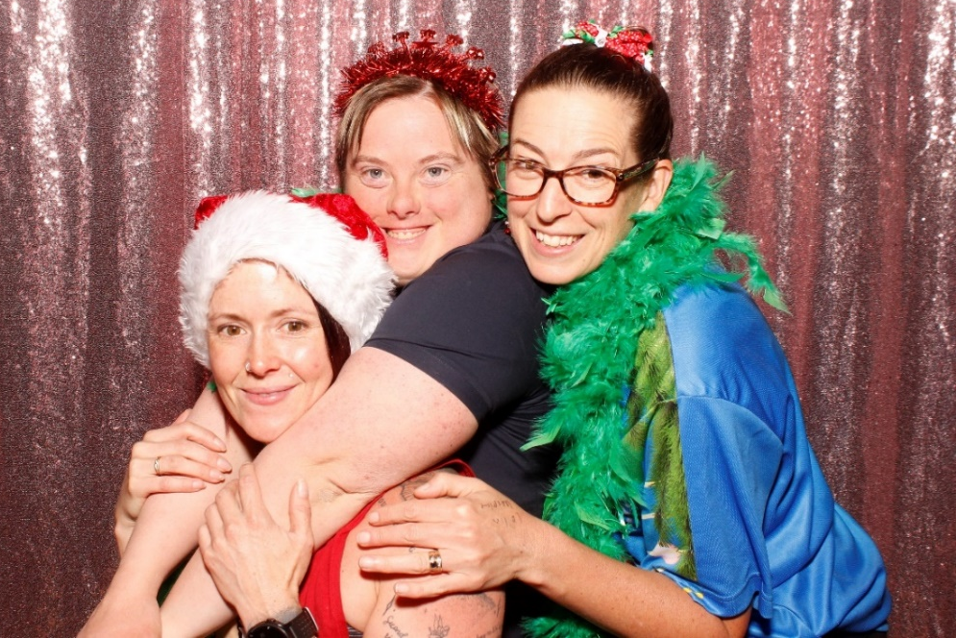

Example: Shire employee, Brooke McQueen celebrates the end of the year and International Day of People with Disability with colleagues at the Margaret River Recreation Centre.

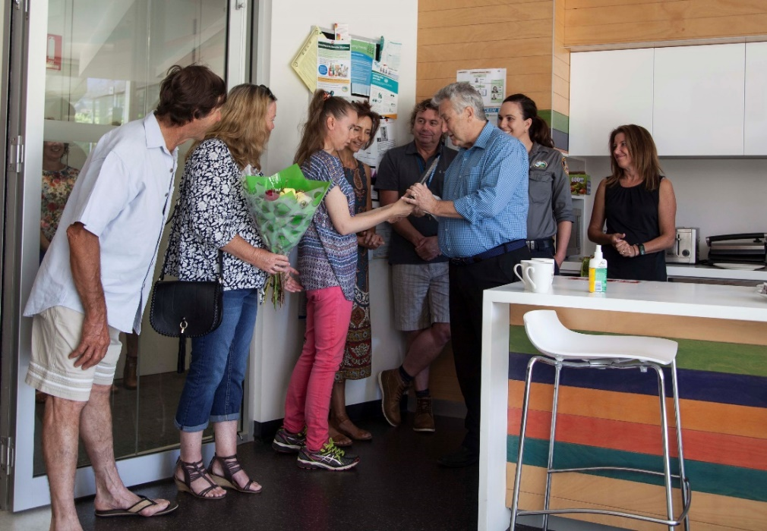

Example: Shire employee, Teneal Duggan is presented with a thank you gift to mark 15-years employment at an all-staff celebratory morning tea.
“The path hasn't always been easy, but the Shire has been amazing. Teneal is a very lucky young lady, and we are so very appreciative of the opportunity that the Shire has given her.” Trina and Peter Duggan, Teneal’s parents

What did we hear?
The Shire was recognised for providing employment for people with disability, however we know that more work needs to be done to increase opportunities for people of all abilities.

Priority strategies:

Increase employment opportunities for people of all abilities
Key actions:
- Review Shire job vacancy advertisements and platforms for potential barriers to applying for Shire positions.
- Promote employment opportunities to disability employment agencies.
- Investigate the feasibility of a traineeship/modified roles that support people with disability to gain new skills to enter or return to the workforce.

Ensure Shire worksites are welcoming and inclusive of all abilities and backgrounds
Key strategies:
- Accessibility audit of Shire worksites.
- Review non-gender specific toilets at Shire worksites.
- Workplace diversity and inclusion training opportunities for all employees.

Continuing strategies:
- Promote and provide volunteering opportunities with the Shire that are inclusive and accessible.
- Maintain effective relationships with local disability employment agencies to facilitate recruitment of people with all abilities.

Outcome eight: Capacity building
Vision: A community that’s supported and empowered to achieve access and inclusion outcomes.
Mission: To improve the community’s understanding and knowledge of access and inclusion.

Building community capacity is a new outcome area introduced in this Access and Inclusion Plan.

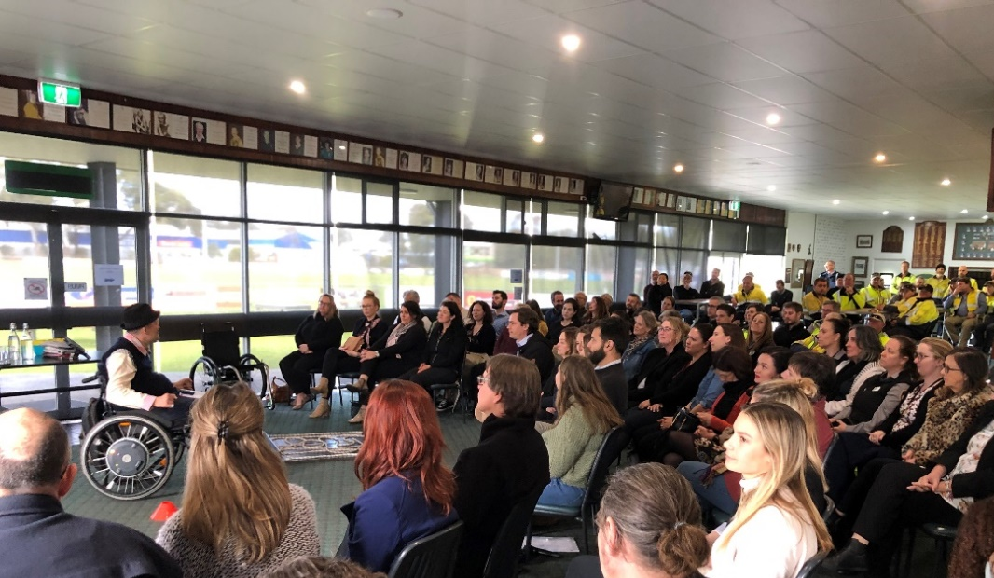
Example: Accessibility training and awareness delivered to all employees at a Shire All Staff Meeting.

Priority strategies:

Improve accessibility within local businesses
Key actions:
- Provide workshops and training opportunities for local business owners and staff.
- Partner with local Chambers and business networks on appropriate capacity building events.
- Encourage considerations for access through Shire permits and approvals.
- Investigate the feasibility of an Access and Inclusion Business Award and / or an Employee Award.

Increase the community’s capacity to build more accessible and inclusive communities
Key action:
- Provide workshops and training opportunities for community members, sporting clubs and community groups.

How will this Plan be implemented?

The implementation of this Plan extends across the whole organisation.

Each business unit within the Shire will be responsible for developing, delivering, and reporting on individual implementation plans and consulting regularly with the Shire’s Community Access and Inclusion Reference Group (CAIRG).

Individual plans will combine to form an all of Shire implementation plan, listing dozens of strategies and actions being rolled out across the organisation.

At the end of each financial year, a Community Development officer will conduct an internal review with each business unit, to gain an update on their progress.

The key achievements identified across the organisation will be presented in the Shire’s Annual Report as well as in an annual report to the Department of Communities. Key initiatives may then be included in the Department’s report to the Minister of Disability Services, along with achievements from other public authorities.

The Shire will also ensure that agents and contractors undertaking work with the community on our behalf report annually on how they have implemented the principles of the Plan.

If you would like a copy of the Shire’s internal implementation plans, past reports or contractor reports, please contact the Community Development Team by calling 9780 5255 or by emailing communitydevelopment@amrshire.wa.gov.au.


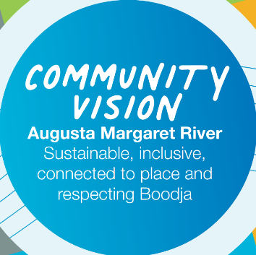
Alignment to the
Strategic Community Plan
2040
Environment  We will protect and enhance the unique natural environment and biodiversity of the region through climate action and informed decision making.  We will focus on:  Outcome EN.1: Ecology and biodiversity protection  Outcome EN.2: Healthy waterways, foreshores and natural landscapes  Outcome EN.3: Collective climate action  Outcome EN.4: Sustainable resource and waste management | People  We will support and strengthen our diverse, resilient, welcoming, safe and connected community through our services and advocacy.  We will focus on:  Outcome PE.1: Diverse cultural values are respected and adopted  Outcome PE.2: Equal opportunities for all  Outcome PE.3: Active, healthy and fulfilling lifestyles  Outcome PE.4: Safe and resilient communities
Place  We will responsibly develop vibrant, sustainable places which maintain their distinctive characters, and which supports a local economy that is resilient, equitable and sustainable.  We will focus on:  Outcome PL.1: Diverse, sustainable and well-designed places  Outcome PL.2: Infrastructure which caters to need  Outcome PL.3: Sustainable agriculture and thriving rural community  Outcome PL.4: Resilient circular local economy | Performance  We will deliver quality governance, service and value with integrity and transparency.  We will focus on:  Outcome PF.1: Responsible planning and ownership of outcomes  Outcome PF.2: Community and customer focus  Outcome PF.3: High performing and engaged people  Outcome PF.4: A culture of innovation, quality and continuous improvement

How does this Plan support the Shire’s strategic goals?

Building a more accessible and inclusive community is integral to the Shire achieving its long-term strategic goals.

Strategic Community Plan 2040

Community Vision: Augusta Margaret River - Sustainable, inclusive, connected to place and respecting Boodja.

Purpose: The Shire of Augusta Margaret River exists to provide, facilitate and
advocate for services, facilities and Boodja, to improve quality of life for everyone in our community.

Future Focus Area - People: We will support and strengthen our diverse, resilient, welcoming, safe and connected community through our services and advocates.

Core Principles: Community belonging, compassion, kindness, and equity.

Strengthening Community Capacity Policy

Each community member has knowledge and skills which are valued. Partnerships and active empowerment are central to how we celebrate and respect our community.

