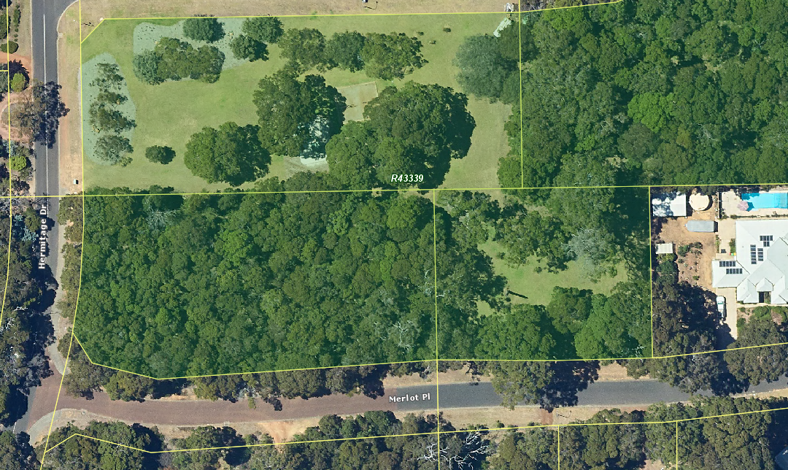
 | The Shire of Augusta-Margaret River does not warrant the accuracy of information in this publication and any person using or relying upon such information does so on the basis that the Shire of Augusta-Margaret River shall bear no responsibility or liability whatsoever for any errors, faults, defects or omissions in the information. | Merlot Place Proposed additional DEA 2022 | Thursday, 11 August 2022 | 
 |  | Merlot Place Proposed additional DEA 2022 | 1:682

